**\*\*\*\* DW Middletown cluster RAC conversion\*\*\*\*\*\***

**Login as grid user to NodeA**

srvctl config scan_listener

srvctl modify scan_listener -endpoints ‘TCP:1551’

srvctl config scan_listener

**Just to verify**

cd $TNS_ADMIN

view listener.ora

**Bounce listener**

srvctl stop scan_listener

srvctl start scan_listener

**Login to Node A under oracle**

ps -ef | grep pmon

sqlplus / as sysdba

## Should be already set just verify if not set to appropriate value

show parameter remote_listener

xhepydbw2p-scan:1551

alter system set remote_listener=’xxx-scan:1551’;

dgmgrl /

show configuration

show database verbose ‘HEDWPRD_xhedwdbm2pcl’

edit database 'HEDWPRD_xhedwdbm2pcl' set property DGConnectIdentifier = '(DESCRIPTION=(ADDRESS=(PROTOCOL=TCP)(HOST= xhedwdbm2p-scan.aetna.com)(PORT=1551))(CONNECT_DATA=(service_name=HEDWPRD_xhedwdbm2pcl)))';

show database verbose ‘HEDWPRD_xhedwdbm2pcl’

**Login to NodeA as grid**

srvctl config listener -l listener

srvctl modify listener -l listener -endpoints ‘TCP:1521,1551/IPC:HEDWPRD_IPC’

srvctl config listener -l listener

cd $TNS_ADMIN

vi listener.ora

Make changes to look like this (Double check with Rich on below)

Remove all similar to that.

~~(ADDRESS = (PROTOCOL = IPC)(KEY = HEPYPRD_IPC))~~

~~(ADDRESS = (PROTOCOL = tcp)(host = xhepydbm2ap)(port = 1655))~~

~~SID_LIST_LISTENER =~~

~~(SID_LIST =~~

~~# HEPYDBA Begin ANSIBLE MANAGED BLOCK~~

~~(SID_DESC =~~

~~(ORACLE_HOME = /oradb/app/oracle/product/19.22.0/db_1)~~

~~(SID_NAME = HEPYDBA)~~

~~)~~

~~# HEPYDBA End ANSIBLE MANAGED BLOCK~~

~~)~~

~~HEDWSTS example~~

~~(ADDRESS = (PROTOCOL = IPC)(KEY = HEDWSTS_IPC))~~

lsnrctl status

Bounce listener

lsnrctl stop listener

lsnrctl start listener

**Login to NodeA under oracle**

cd $TNS_ADMIN

vi tnsnames.ora

**Change port to 1551**

**Same on NodeB**

**## Stop service on just in case on both NodeA and NodeB**

**exec DBMS_SERVICE.STOP_SERVICE('HEDWPRD_RPT');**

**Add Targets to OEM if not already there. You may need to ask Rich so he can re discover target after converstion to RACONE**

**Update OEM targets with 1551 port if needed.**

Login to OEM as sysman

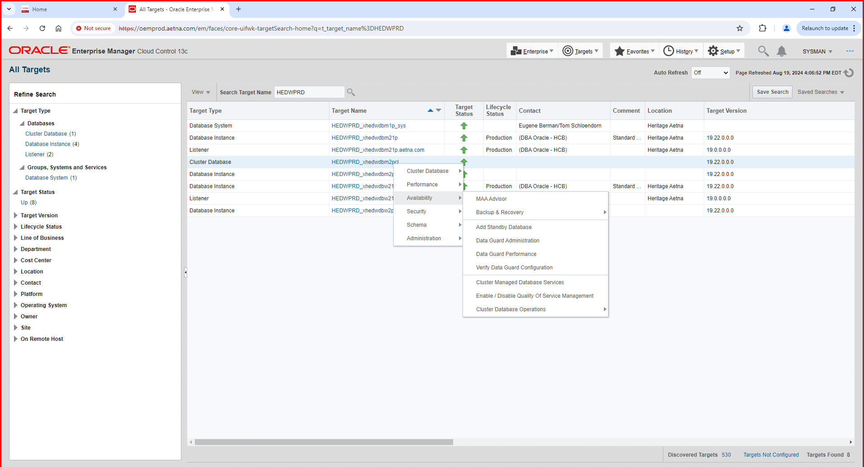

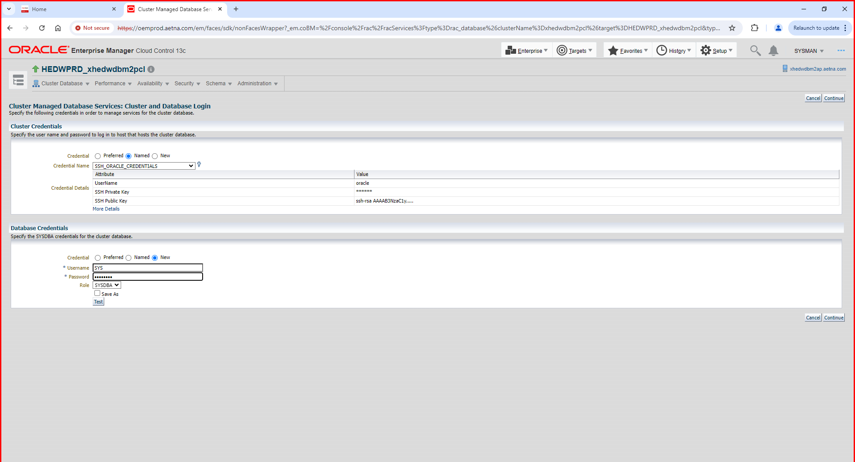

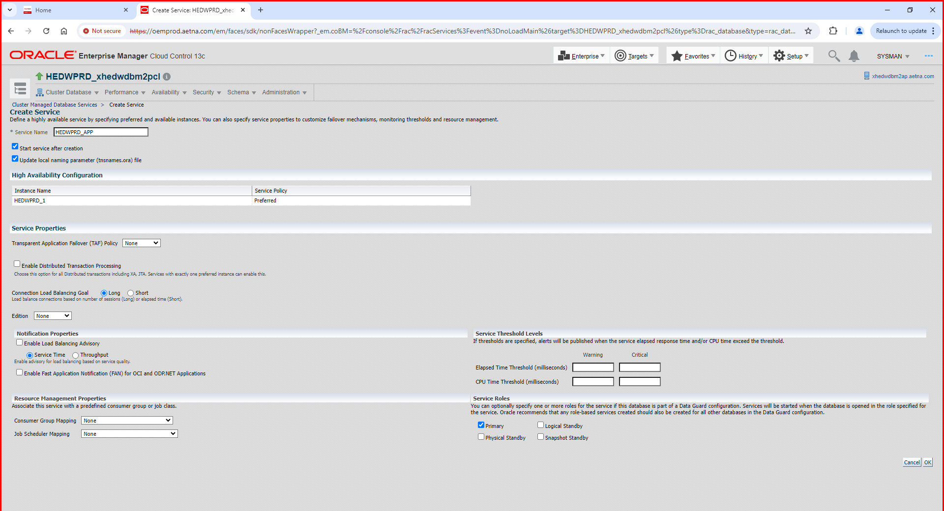

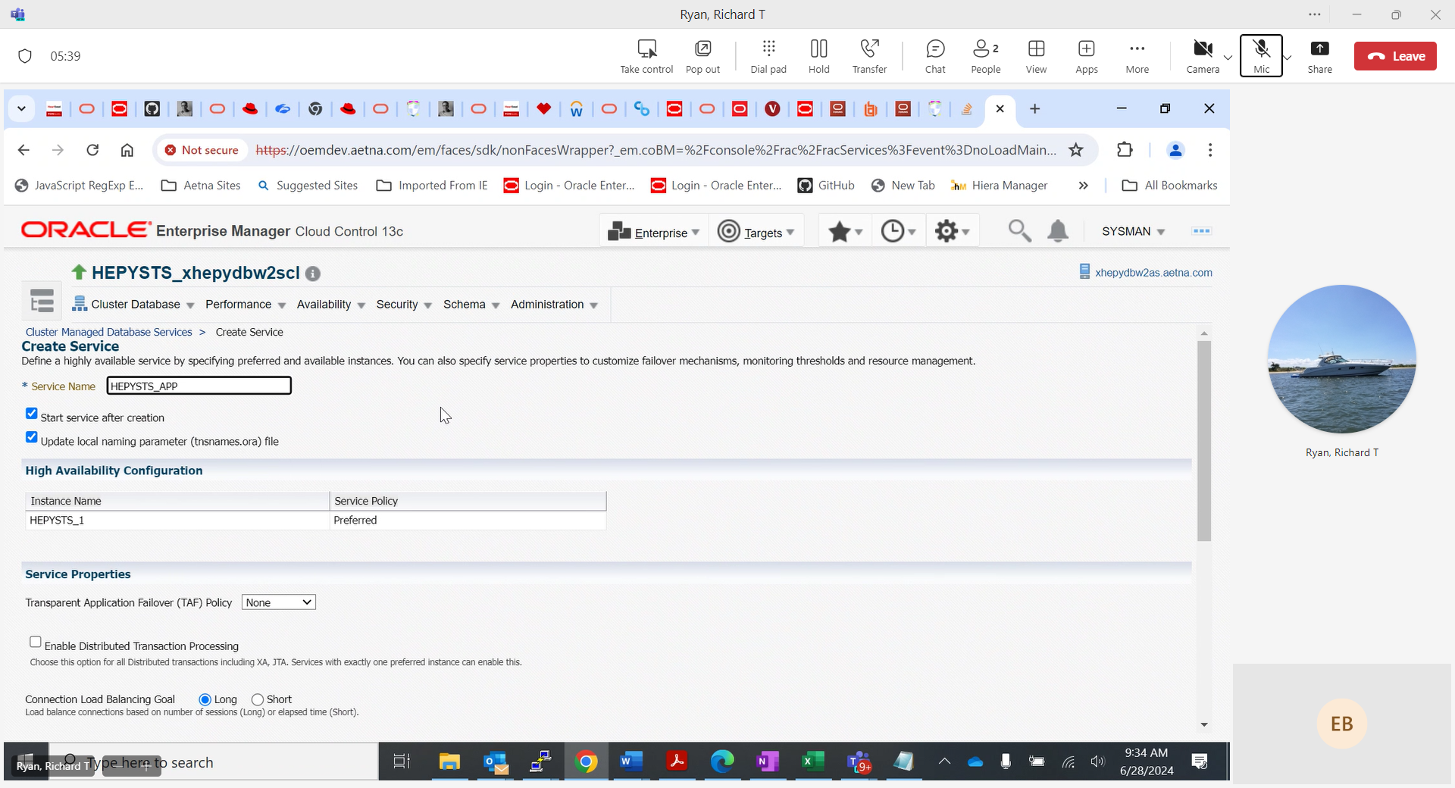

Do the same for HEDWPRD_RPT service

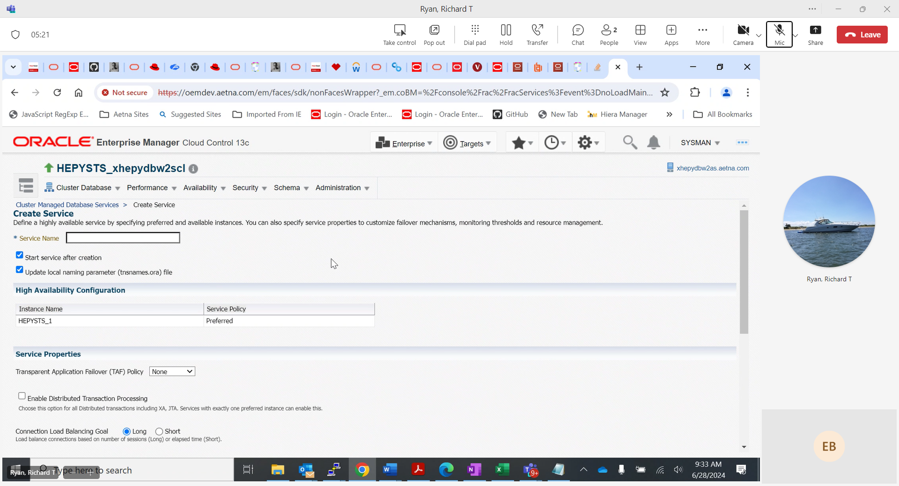

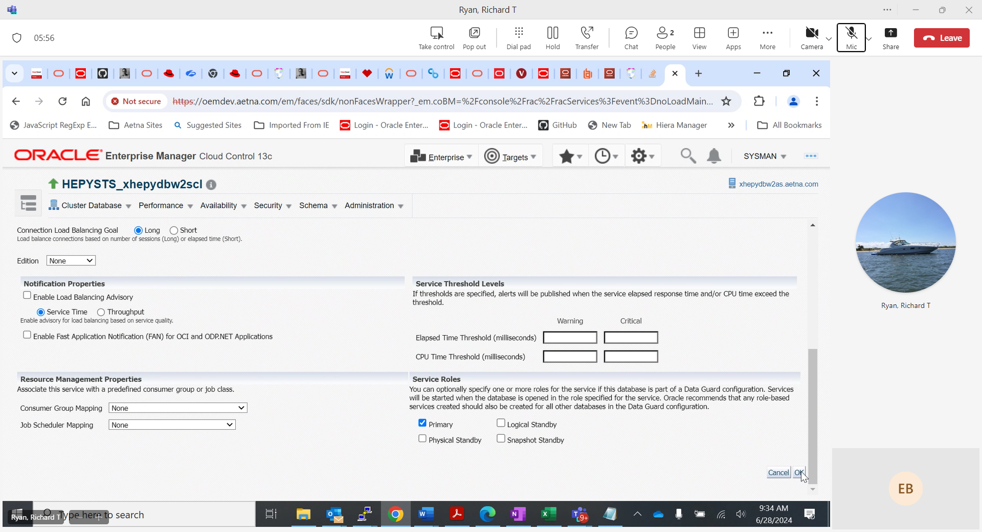

**Login to NodeA as oracle**

srvctl config service -d HEDWPRD_xhedwdbm2pcl -s HEDWPRD_APP

srvctl status service -d HEDWPRD_xhedwdbm2pcl -s HEDWPRD_APP

srvctl config service -d HEDWPRD_xhedwdbm2pcl -s HEDWPRD_RPT

srvctl status service -d HEDWPRD_xhedwdbm2pcl -s HEDWPRD_RPT

## in case services are up

select * from dba_services;

exec DBMS_SERVICE.STOP_SERVICE('HEDWPRD_APP');

exec DBMS_SERVICE.STOP_SERVICE('HEDWPRD_RPT');

srvctl disable service -db HEDWPRD_xhedwdbm2pcl -service HEDWPRD_APP

srvctl disable service -db HEDWPRD_xhedwdbm2pcl -service HEDWPRD_RPT

Modify tnsnames. ora entry on both NodeA and NodeB. Add HEDWPRD_APP service entry

cd $TNS_ADMIN

vi tnsnames.ora

HEDWPRD_APP =

(DESCRIPTION =

(ADDRESS = (PROTOCOL = TCP)(HOST = xhedwdbm2p-scan.aetna.com)(PORT = 1551))

(CONNECT_DATA =

(SERVER = DEDICATED)

(service_name = HEDWPRD_APP)

)

)

~~Do it on Nodeb tnsnames.ora as well~~

~~Double check to make sure HEDWPRD_APP service role set to PRIMARY and it not running before switch over.~~

~~How to test connection strings~~

~~srvctl start service -d HEDWPRD_xhedwdbm2pcl -s HEDWPRD_APP~~

~~from any none RAC boxes~~

~~sqlplus AID/xxx@'(DESCRIPTION = (ADDRESS_LIST = (ADDRESS = (PROTOCOL = TCP)(HOST = xhedwdb2p-scan.aetna.com)(PORT = 1551)) (ADDRESS = (PROTOCOL = TCP)(HOST = xhedwdbm21p.aetna.com)(PORT = 1575))) (CONNECT_DATA = (SERVICE_NAME = HEDWPRD_APP)))'~~

~~sqlplus AID/xxx@'(DESCRIPTION=(ADDRESS=(PROTOCOL=tcp)(HOST= xhedwdbm21p.aetna.com)(PORT=1575))(CONNECT_DATA=(SID= HEDWPRD)))'~~

~~srvctl stop service -d HEDWPRD_xhedwdbm2pcl -s HEDWPRD_APP~~

**\*\*\*\* DW Windsor cluster RAC conversion\*\*\*\*\*\***

**Login as grid user to NodeA**

srvctl config scan_listener

srvctl modify scan_listener -endpoints ‘TCP:1551’

srvctl config scan_listener

**Just to verify**

cd $TNS_ADMIN

view listener.ora

**Bounce listener**

srvctl stop scan_listener

srvctl start scan_listener

**Login to NodeA as grid**

srvctl config listener -l listener

srvctl modify listener -l listener -endpoints ‘TCP:1521,1551/IPC:HEDWPRD_IPC’

srvctl config listener -l listener

cd $TNS_ADMIN

vi listener.ora

Make changes to look like this (Double check with Rich on below)

Remove all similar to that.

~~(ADDRESS = (PROTOCOL = IPC)(KEY = HEPYPRD_IPC))~~

~~(ADDRESS = (PROTOCOL = tcp)(host = xhepydbm2ap)(port = 1655))~~

~~SID_LIST_LISTENER =~~

~~(SID_LIST =~~

~~# HEPYDBA Begin ANSIBLE MANAGED BLOCK~~

~~(SID_DESC =~~

~~(ORACLE_HOME = /oradb/app/oracle/product/19.22.0/db_1)~~

~~(SID_NAME = HEPYDBA)~~

~~)~~

~~# HEPYDBA End ANSIBLE MANAGED BLOCK~~

~~)~~

~~HEDWSTS example~~

~~(ADDRESS = (PROTOCOL = IPC)(KEY = HEDWSTS_IPC))~~

lsnrctl status

Bounce listener

srvctl stop listener -l listener

srvctl start listener -l listener

~~lsnrctl stop listener~~

~~lsnrctl start listener~~

**Login to Node A under oracle**

ps -ef | grep pmon

sqlplus / as sysdba

show parameter remote_listener

## Should be already set if not set to appropriate value

xhedwdbw2p-scan:1551

alter system set remote_listener=’xhedwdbw2p-scan:1551’;

dgmgrl /

show configuration

Configuration - HEDWPRD

Protection Mode: MaxPerformance

Members:

HEDWPRD_xhedwdbm21p - Primary database

HEDWPRD_xhedwdbw21p - Physical standby database

HEDWPRD_xhedwdbm2pcl - Physical standby database

HEDWPRD_xhedwdbw2pcl - Physical standby database

Fast-Start Failover: Disabled

Configuration Status:

SUCCESS (status updated 803 seconds ago)

show database verbose ‘HEDWPRD_xhedwdbw2pcl’

edit database 'HEDWPRD_xhedwdbw2pcl' set property DGConnectIdentifier = '(DESCRIPTION=(ADDRESS=(PROTOCOL=TCP)(HOST= xhedwdbw2p-scan.aetna.com)(PORT=1551))(CONNECT_DATA=(service_name=HEDWPRD_xhedwdbw2pcl)))';

show database verbose ‘HEDWPRD_xhedwdbw2pcl’

**Login to NodeA under oracle**

cd $TNS_ADMIN

vi tnsnames.ora

**Change port to 1551**

**Repeat above on NodeB**

**## Stop service on just in case on both NodeA and NodeB**

**cd $SQLPATH**

**sqlplus / as sysdba**

**@whoson.sql**

**exec DBMS_SERVICE.STOP_SERVICE('HEDWPRD_RPT');**

**Add Targets to OEM if not already there. You may need to ask Rich so he can re discover target after converstion to RACONE**

**Update OEM targets with 1551 port if needed.**

**Add ARCHIVE LOG PURGE and LOG and TRIM Purge jobs if needed.**

Login to OEM as sysman

Select database target: HEDWPRD

Right mouse click on Cluster Database Target 🡪 Availability 🡪 Cluster Managed Database Services





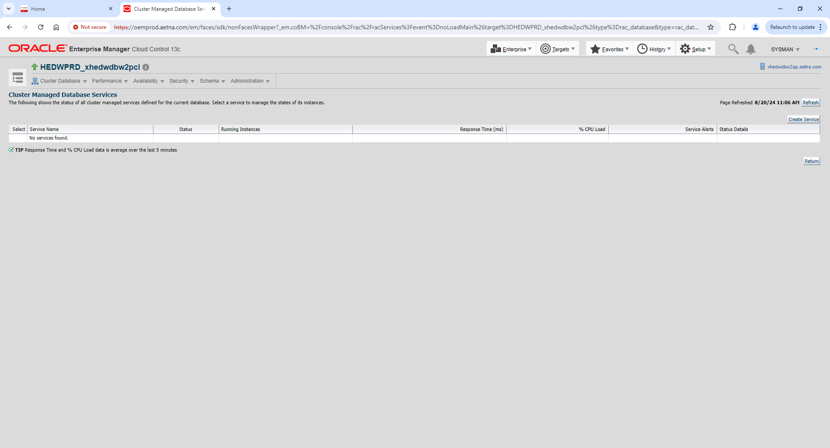

Click Create Service button



Click OK

Do the same for HEDWPRD_RPT service

**##If you see following error it would be expected because database opened in mount mode.**

An error occurred when executing the operation. Ensure that CRS processes and SRVCTL are functioning properly. Refresh the page to see the current status. Refer to the following error: Srvctl command: /oradb/app/oracle/product/19.22.0/db_1/bin/srvctl add service -d HEDWPRD_xhedwdbw2pcl -s HEDWPRD_APP -l PRIMARY -P NONE -j LONG -B NONE -q false -x false Srvctl command: /oradb/app/oracle/product/19.22.0/db_1/bin/srvctl start service -d HEDWPRD_xhedwdbw2pcl -s HEDWPRD_APP PRCD-1133 : failed to start services hedwprd_app for database HEDWPRD_xhedwdbw2pcl PRCR-1095 : Failed to start resources using filter ((NAME == ora.hedwprd_xhedwdbw2pcl.hedwprd_app.svc) AND (TYPE == ora.service.type)) CRS-2800: Cannot start resource 'ora.hedwprd_xhedwdbw2pcl.db' as it is already in the INTERMEDIATE state on server 'xhedwdbw2ap' CRS-2527: Unable to start 'ora.hedwprd_xhedwdbw2pcl.hedwprd_app.svc' because it has a 'hard' dependency on 'ora.hedwprd_xhedwdbw2pcl.db' CRS-2525: All instances of the resource 'ora.hedwprd_xhedwdbw2pcl.db' are already running; relocate is not allowed because the force option was not specified

**Login to NodeA as oracle**

srvctl config service -d HEDWPRD_xhedwdbw2pcl -s HEDWPRD_APP

srvctl status service -d HEDWPRD_xhedwdbw2pcl -s HEDWPRD_APP

srvctl config service -d HEDWPRD_xhedwdbw2pcl -s HEDWPRD_RPT

srvctl status service -d HEDWPRD_xhedwdbw2pcl -s HEDWPRD_RPT

**## in case services are up on NodeA and NodeB**

select * from dba_services;

exec DBMS_SERVICE.STOP_SERVICE('HEDWPRD_APP');

exec DBMS_SERVICE.STOP_SERVICE('HEDWPRD_RPT');

srvctl disable service -db HEDWPRD_xhedwdbw2pcl -service HEDWPRD_APP

srvctl disable service -db HEDWPRD_xhedwdbw2pcl -service HEDWPRD_RPT

**Modify tnsnames. ora entry on both NodeA and NodeB. Add HEDWPRD_APP service entry**

cd $TNS_ADMIN

vi tnsnames.ora

HEDWPRD_APP =

(DESCRIPTION =

(ADDRESS = (PROTOCOL = TCP)(HOST = xhedwdbw2p-scan.aetna.com)(PORT = 1551))

(CONNECT_DATA =

(SERVER = DEDICATED)

(service_name = HEDWPRD_APP)

)

)

**\*\*\*\* PY Middletown cluster RAC conversion\*\*\*\*\*\***

**Login as grid user to NodeA**

srvctl config scan_listener

srvctl modify scan_listener -endpoints 'TCP:1551'

srvctl config scan_listener

**Just to verify**

cd $TNS_ADMIN

view listener.ora

**Bounce listener**

srvctl stop scan_listener

srvctl start scan_listener

**Login to NodeA as grid**

srvctl config listener -l listener

srvctl modify listener -l listener -endpoints ‘TCP:1521,1551/IPC:HEPYPRD_IPC’

srvctl config listener -l listener

cd $TNS_ADMIN

vi listener.ora

Make changes to look like this (Double check with Rich on below)

Remove all similar to that.

~~(ADDRESS = (PROTOCOL = IPC)(KEY = HEPYPRD_IPC))~~

~~(ADDRESS = (PROTOCOL = tcp)(host = xhepydbm2ap)(port = 1655))~~

~~SID_LIST_LISTENER =~~

~~(SID_LIST =~~

~~# HEPYDBA Begin ANSIBLE MANAGED BLOCK~~

~~(SID_DESC =~~

~~(ORACLE_HOME = /oradb/app/oracle/product/19.22.0/db_1)~~

~~(SID_NAME = HEPYDBA)~~

~~)~~

~~# HEPYDBA End ANSIBLE MANAGED BLOCK~~

~~)~~

~~HEDWSTS example~~

~~(ADDRESS = (PROTOCOL = IPC)(KEY = HEDWSTS_IPC))~~

lsnrctl status

Bounce listener

srvctl stop listener -l listener

srvctl start listener -l listener

~~lsnrctl stop listener~~

~~lsnrctl start listener~~

**Login to Node A under oracle**

ps -ef | grep pmon

sqlplus / as sysdba

show parameter remote_listener

## Should be already set if not set to appropriate value

xhepydbm2p-scan:1551

alter system set remote_listener=’xhepydbm2p-scan:1551’;

dgmgrl /

show configuration

Configuration - HEPYPRD

Protection Mode: MaxPerformance

Members:

HEPYPRD_xhepydbm1p - Primary database

HEPYPRD_xhepydbw21p - Physical standby database

HEPYPRD_xhepydbm2pcl - Physical standby database (disabled)

HEPYPRD_xhepydbw2pcl - Physical standby database

Fast-Start Failover: Disabled

Configuration Status:

SUCCESS (status updated 47 seconds ago

show database verbose ‘HEPYPRD_xhepydbm2pcl’

edit database 'HEPYPRD_xhepydbm2pcl' set property DGConnectIdentifier = '(DESCRIPTION=(ADDRESS=(PROTOCOL=TCP)(HOST= xhepydbm2p-scan.aetna.com)(PORT=1551))(CONNECT_DATA=(service_name=HEPYPRD_xhepydbm2pcl)))';

show database verbose ‘HEPYPRD_xhepydbm2pcl’

**Login to NodeA under oracle**

cd $TNS_ADMIN

vi tnsnames.ora

**Change port to 1551**

**Repeat above on NodeB**

**## Stop service on just in case on both NodeA and NodeB**

**cd $SQLPATH**

**sqlplus / as sysdba**

**@whoson.sql**

**select name from v$active_services;**

**exec DBMS_SERVICE.STOP_SERVICE('HEPYPRD_RPT');**

**Add Targets to OEM if not already there. You may need to ask Rich so he can re discover target after converstion to RACONE**

**Update OEM targets with 1551 port if needed.**

**Add ARCHIVE LOG PURGE and LOG and TRIM Purge jobs if needed.**

Login to OEM as sysman

Select database target: HEPYPRD

Right mouse click on Cluster Database Target 🡪 Availability 🡪 Cluster Managed Database Services







Click Create Service button

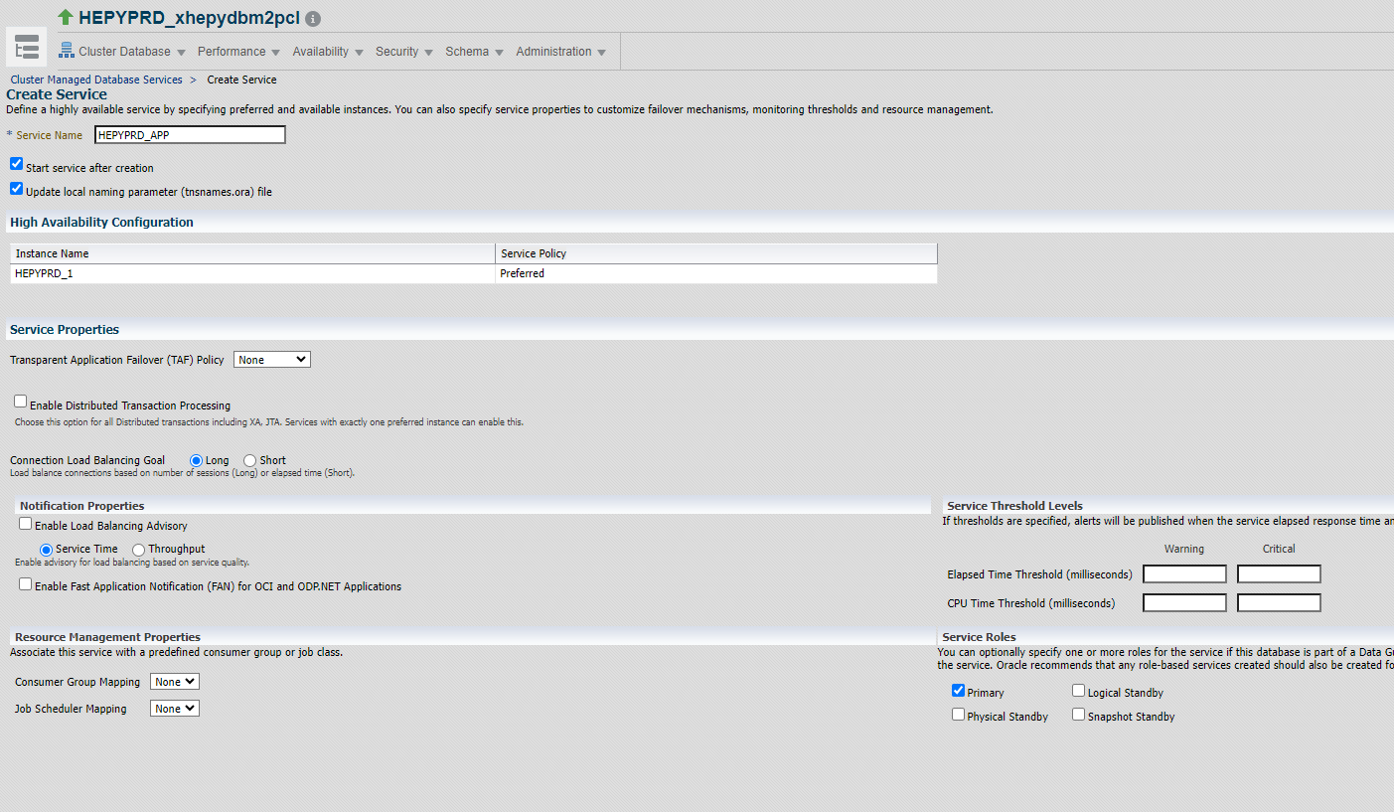

Click OK

Do the same for HEPYPRD_RPT service

**##If you see following error it would be expected because database opened in mount mode.**

An error occurred when executing the operation. Ensure that CRS processes and SRVCTL are functioning properly. Refresh the page to see the current status. Refer to the following error: Srvctl command: /oradb/app/oracle/product/19.22.0/db_1/bin/srvctl add service -d HEDWPRD_xhedwdbw2pcl -s HEDWPRD_APP -l PRIMARY -P NONE -j LONG -B NONE -q false -x false Srvctl command: /oradb/app/oracle/product/19.22.0/db_1/bin/srvctl start service -d HEDWPRD_xhedwdbw2pcl -s HEDWPRD_APP PRCD-1133 : failed to start services hedwprd_app for database HEDWPRD_xhedwdbw2pcl PRCR-1095 : Failed to start resources using filter ((NAME == ora.hedwprd_xhedwdbw2pcl.hedwprd_app.svc) AND (TYPE == ora.service.type)) CRS-2800: Cannot start resource 'ora.hedwprd_xhedwdbw2pcl.db' as it is already in the INTERMEDIATE state on server 'xhedwdbw2ap' CRS-2527: Unable to start 'ora.hedwprd_xhedwdbw2pcl.hedwprd_app.svc' because it has a 'hard' dependency on 'ora.hedwprd_xhedwdbw2pcl.db' CRS-2525: All instances of the resource 'ora.hedwprd_xhedwdbw2pcl.db' are already running; relocate is not allowed because the force option was not specified

**Login to NodeA as oracle**

srvctl config service -d HEPYPRD_xhepydbm2pcl -s HEPYPRD_APP

srvctl status service -d HEPYPRD_xhepydbm2pcl -s HEPYPRD_APP

srvctl config service -d HEPYPRD_xhepydbm2pcl -s HEPYPRD_RPT

srvctl status service -d HEPYPRD_xhepydbm2pcl -s HEPYPRD_RPT

**## in case services are up on NodeA and NodeB**

select * from dba_services;

exec DBMS_SERVICE.STOP_SERVICE('HEPYPRD_APP');

exec DBMS_SERVICE.STOP_SERVICE('HEPYPRD_RPT');

srvctl disable service -db HEPYPRD_xhepydbm2pcl -service HEPYPRD_APP

srvctl disable service -db HEPYPRD_xhepydbm2pcl -service HEPYPRD_RPT

**Modify tnsnames. ora entry on both NodeA and NodeB. Add HEPYPRD_APP service entry**

cd $TNS_ADMIN

vi tnsnames.ora

HEPYPRD_APP =

(DESCRIPTION =

(ADDRESS = (PROTOCOL = TCP)(HOST = xhepydbm2p-scan.aetna.com)(PORT = 1551))

(CONNECT_DATA =

(SERVER = DEDICATED)

(service_name = HEPYPRD_APP)

)

)

**E.B.**

**\*\*\*\* PY Windsor cluster RAC conversion\*\*\*\*\*\***

**Login as grid user to NodeA**

srvctl config scan_listener

srvctl modify scan_listener -endpoints 'TCP:1551'

srvctl config scan_listener

**Just to verify**

cd $TNS_ADMIN

view listener.ora

**Bounce listener**

srvctl stop scan_listener

srvctl start scan_listener

**Login to NodeA as grid**

srvctl config listener -l listener

srvctl modify listener -l listener -endpoints ‘TCP:1521,1551/IPC:HEPYPRD_IPC’

srvctl config listener -l listener

cd $TNS_ADMIN

vi listener.ora

Make changes to look like this (Double check with Rich on below)

Remove all similar to that.

~~(ADDRESS = (PROTOCOL = IPC)(KEY = HEPYPRD_IPC))~~

~~(ADDRESS = (PROTOCOL = tcp)(host = xhepydbm2ap)(port = 1655))~~

~~SID_LIST_LISTENER =~~

~~(SID_LIST =~~

~~# HEPYDBA Begin ANSIBLE MANAGED BLOCK~~

~~(SID_DESC =~~

~~(ORACLE_HOME = /oradb/app/oracle/product/19.22.0/db_1)~~

~~(SID_NAME = HEPYDBA)~~

~~)~~

~~# HEPYDBA End ANSIBLE MANAGED BLOCK~~

~~)~~

~~HEDWSTS example~~

~~(ADDRESS = (PROTOCOL = IPC)(KEY = HEDWSTS_IPC))~~

lsnrctl status

Bounce listener

srvctl stop listener -l listener

srvctl start listener -l listener

~~lsnrctl stop listener~~

~~lsnrctl start listener~~

**Login to Node A under oracle**

ps -ef | grep pmon

sqlplus / as sysdba

show parameter remote_listener

## Should be already set if not set to appropriate value

xhepydbw2p-scan:1551

alter system set remote_listener=’xhepydbw2p-scan:1551’;

dgmgrl /

show configuration

Configuration - HEPYPRD

Protection Mode: MaxPerformance

Members:

HEPYPRD_xhepydbm1p - Primary database

HEPYPRD_xhepydbw21p - Physical standby database

HEPYPRD_xhepydbm2pcl - Physical standby database (disabled)

HEPYPRD_xhepydbw2pcl - Physical standby database

Fast-Start Failover: Disabled

Configuration Status:

SUCCESS (status updated 47 seconds ago

show database verbose ‘HEPYPRD_xhepydbw2pcl’

edit database 'HEPYPRD_xhepydbw2pcl' set property DGConnectIdentifier = '(DESCRIPTION=(ADDRESS=(PROTOCOL=TCP)(HOST= xhepydbw2p-scan.aetna.com)(PORT=1551))(CONNECT_DATA=(service_name=HEPYPRD_xhepydbw2pcl)))';

show database verbose ‘HEPYPRD_xhepydbw2pcl’

**Login to NodeA under oracle**

cd $TNS_ADMIN

vi tnsnames.ora

**Change port to 1551**

**Repeat above on NodeB**

**## Stop service on just in case on both NodeA and NodeB**

**cd $SQLPATH**

**sqlplus / as sysdba**

**@whoson.sql**

**select name from v$active_services;**

**exec DBMS_SERVICE.STOP_SERVICE('HEPYPRD_RPT');**

**Add Targets to OEM if not already there for Cluster Database.**

**You may need to ask Rich so he can re discover target after converstion to RACONE**

**Update OEM targets with 1551 port if needed.**

**Add ARCHIVE LOG PURGE and LOG and TRIM Purge jobs if needed.**

Login to OEM as sysman

Select database target: HEPYPRD

Right mouse click on Cluster Database Target 🡪 Availability 🡪 Cluster Managed Database Services







Click Create Service button



Click OK

Do the same for HEPYPRD_RPT service

**##If you see following error it would be expected because database opened in mount mode.**

An error occurred when executing the operation. Ensure that CRS processes and SRVCTL are functioning properly. Refresh the page to see the current status. Refer to the following error: Srvctl command: /oradb/app/oracle/product/19.22.0/db_1/bin/srvctl add service -d HEDWPRD_xhedwdbw2pcl -s HEDWPRD_APP -l PRIMARY -P NONE -j LONG -B NONE -q false -x false Srvctl command: /oradb/app/oracle/product/19.22.0/db_1/bin/srvctl start service -d HEDWPRD_xhedwdbw2pcl -s HEDWPRD_APP PRCD-1133 : failed to start services hedwprd_app for database HEDWPRD_xhedwdbw2pcl PRCR-1095 : Failed to start resources using filter ((NAME == ora.hedwprd_xhedwdbw2pcl.hedwprd_app.svc) AND (TYPE == ora.service.type)) CRS-2800: Cannot start resource 'ora.hedwprd_xhedwdbw2pcl.db' as it is already in the INTERMEDIATE state on server 'xhedwdbw2ap' CRS-2527: Unable to start 'ora.hedwprd_xhedwdbw2pcl.hedwprd_app.svc' because it has a 'hard' dependency on 'ora.hedwprd_xhedwdbw2pcl.db' CRS-2525: All instances of the resource 'ora.hedwprd_xhedwdbw2pcl.db' are already running; relocate is not allowed because the force option was not specified

**Login to NodeA as oracle**

srvctl config service -d HEPYPRD_xhepydbw2pcl -s HEPYPRD_APP

srvctl status service -d HEPYPRD_xhepydbw2pcl -s HEPYPRD_APP

srvctl config service -d HEPYPRD_xhepydbw2pcl -s HEPYPRD_RPT

srvctl status service -d HEPYPRD_xhepydbw2pcl -s HEPYPRD_RPT

**## in case services are up on NodeA and NodeB**

select * from dba_services;

exec DBMS_SERVICE.STOP_SERVICE('HEPYPRD_APP');

exec DBMS_SERVICE.STOP_SERVICE('HEPYPRD_RPT');

srvctl disable service -db HEPYPRD_xhepydbw2pcl -service HEPYPRD_APP

srvctl disable service -db HEPYPRD_xhepydbw2pcl -service HEPYPRD_RPT

**Modify tnsnames. ora entry on both NodeA and NodeB. Add HEPYPRD_APP service entry**

cd $TNS_ADMIN

vi tnsnames.ora

HEPYPRD_APP =

(DESCRIPTION =

(ADDRESS = (PROTOCOL = TCP)(HOST = xhepydbw2p-scan.aetna.com)(PORT = 1551))

(CONNECT_DATA =

(SERVER = DEDICATED)

(service_name = HEPYPRD_APP)

)

)

**\*\*\*\*\* POST RACONE switchover services related changes \*\*\***

**--> HEPYPRD StandBy (in support of this service starting up automatically after db bounce)**

**srvctl modify service -d HEPYPRD_xhepydbw2pcl -service hepyprd_rpt –role “physical_standby”**

**srvctl config service -d HEPYPRD_xhepydbw2pcl -service hepyprd_rpt**

**--> HEDWPRD StandBy (in support of this service starting up automatically after db bounce)**

**srvctl modify service -d HEDWPRD_xhedwdbw2pcl -service hedwprd_rpt –role “physical_standby”**

**srvctl config service -d HEDWPRD_xhedwdbw2pcl -service hedwprd_rpt**

**--> HEPYPRD Primary (in support of this service just being defined in case of failover/switchover roles)**

**srvctl add service -d HEPYPRD_xhepydbm2pcl -service hepyprd_rpt –role “physical_standby”**

**select name from dba_services;**

**select name from v$active_services;**

**If that service is up for some reason stop it.**

**--> HEDWPRD Primary (in support of this service just being defined in case of failover/switchover roles)**

**srvctl add service -d HEDWPRD_xhedwdbm2pcl -service hedwprd_rpt –role “physical_standby”**

**select name from dba_services;**

**select name from v$active_services;**

**If that service is up for some reason stop it.**